**KWAME NKRUMAH UNIVERSITY OF SCIENCE AND TECHNOLOGY**

**COLLEGE OF ENGINEERING**

**DEPARTMENT OF CHEMICAL ENGINEERING**

**TITLE: ESTIMATION OF CALCIUM WITH EDTA**

****

**NAME: DONTOH NANA EDWARD**

**COURSE: BSC. CHEMICAL ENGINEERING**

**YEAR: SECOND YEAR**

**EXPERIMENT NO. : A.1.2.2.**

**I.D. NO: 4736610**

**DEMONSTRATOR: JAMES KWAME KUSI**

**DATE: 21ST MARCH, 2012.**

**Aims and Objectives:**

To determine the weight and percentage of the “available calcium’ in EDTA using titrimetric analysis.

**INTRODUCTION**

Ethylenediamminetetraacetic acid, more commonly known as EDTA belongs to a class of synthetic compounds known as polyaminocarboxylic acids.  Acting as a ligand that shows multiple coordination sites, EDTA forms very strong 1:1 stoichiometric complexes with all +2 and higher charged metal ions in aqueous solution.    
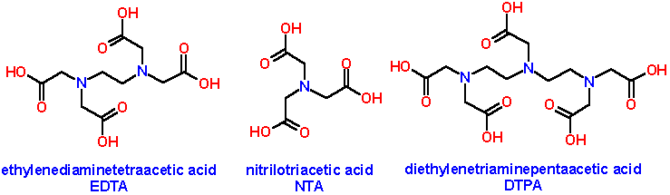  
EDTA contains six sites that can be protonated.  Since EDTA itself is quite insoluble in water, the disodium salt is normally used to make EDTA solutions.  To form the strongest complexes, EDTA solutions are usually buffered in a region that ensures that protonation reactions do not compete with the complexation reaction.  The important species in solution are generally H2Y2-   and HY3-.  Figure 15-4 in your text shows the ideal pH buffer ranges for the EDTA titration of various metal ions.  
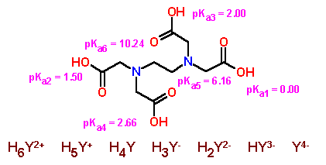

The analytical reaction in this experiment can be written as:  
**Ca2+  +  HY3-  C:\Users\Eddie\Desktop\Second Semester\Analytical Research Materials\CHEMISTRY 221 LABORATORY_files\arrowequildkred.gif  CaY2-  +  H+**note that the reaction has a 1:1 stoichiometry.  Since EDTA forms very strong complexes with most metal ions with a charge greater than +2, procedures designed to "mask" or complex impurity ions are often used.  In this experiment, however, relatively pure calcium carbonate unknowns are used so that masking reagents are not needed.  The overall procedure to be used involves the standardization of an EDTA solution by titration with a known amount of calcium followed by using the calibrated solution to determine an unknown amount of calcium.

**CHEMICALS AND INSTRUMENTS USED**

* 250ml conical flask.
* Pipette.
* Burette.
* Retort stand.
* Conical flask.
* Electronic balance.
* Beakers
* Buffer solution.
* CaCO3
* Dilute HCl

**PROCEDURE**

Weigh out accurately 2.5g of the CaCO3 and transfer into 250ml volumetric flask. Add dilute HCl drop by drop till effervescence ceases and the salt completely dissolves. Dilute to the mark with water. Into a 250ml conical flask, pipette out 10ml the prepared Ca solution. Add 20ml distilled water, 2ml buffer solution and add 5 to 6 drops of the indicator solution. Add EDTA solution from the burette dropwise till the red colour of the solution changes to permanent blue. Repeat titration to get two more concordant values. Calculate the amount of the Ca in the solution.

**TABLE OF VALUES**

|  |  |  |  |
| --- | --- | --- | --- |
| **Burette Readings/cm3** | 1 | 2 | 3 |
| **Final** | 9.00 | 16.50 | 25.60 |
| **Initial** | 0.00 | 9.00 | 16.50 |
| **Titre Value** | 9.00 | 7.50 | 9.10 |

CaCO3+2HCl→CaCl2+H2O+CO2

Average titre = 

V(EDTA) = 9.05cm3

n(EDTA) = [EDTA] x V (EDTA)

= 

= 9.05×10-4mol

This amount is contained in 30ml of the turbid solution.

∴ The amount of Ca in the 250ml

= 

= 7.54×10 -3 mol

⇒m(Cl2) = n(Ca) x M(Ca)

= 7.54×10 -3x 40

**= 0.3016g**

**DISCUSSION**

Ca2+ was determined by titration with ethylenediaminetetraacetic acid (EDTA) at pH 10.

HOOC-CH2 CH2-COOH

NCH2-CH2N

HOOC-CH2 CH2-COOH

Ethylenediaminetetraacetic Acid (EDTA, or H4Y)

If the EDTA molecule is represented as H4Y, where the four acidic hydrogen atoms are those at the “ends” of the molecule, then EDTA dissolved at pH l0 is approximately half in the form of HY3- and half in the form of Y4-. The complexation reaction of EDTA with either Ca2+ or Mg2+ can therefore be represented in either of the following ways, where M2+ represents the metal ion.

M2+  + HY3- MY2- + H+

M2+  + Y4- MY2-

Standard EDTA solutions can be prepared directly from either disodium EDTA (Na2H2Y) or disodium EDTA dihydrate ((Na2H2Y.2H20).

The endpoints of EDTA titrations of Ca2+ and Mg2+ can be located with the metallochromic indicator, Calmagite. This indicator forms a red complex with either Ca2+ or Mg2+. The uncomplexed indicator can exist in the ionic forms H2In-, HIn2-, and In3- (red, blue, orange, respectively). At a pH in the range 8.1 - 12.4, the blue HIn2- form predominates, which is in equilibrium with the red CaIn- when the metal Ca2+  is present.

Ca2+  + H2In- CaIn- + H+

(blue) (red)

Before the endpoint of the titration, the solution is red because of the excess metal ion. As the EDTA titrant complexes more and more metal, the above equilibrium shifts to the left. At the endpoint the solution turns blue. The titration gives the moles of Ca2+ present in the sample.

**CONCLUSION**

With the help of the concentration of EDTA, the amount of Ca was finally determined

**PRECAUTION**

* Equipment was washed before and after each experiment
* The burette readings were taken from below the meniscus.
* The electronic balance was zeroed before readings were taken

**REFERENCES**

General Chemistry by Whitten D. Peck

Vogel’s Textbook of Quantitative Analysis (page 382-383)

Essential Chemistry by Raymond Chang (page 863)